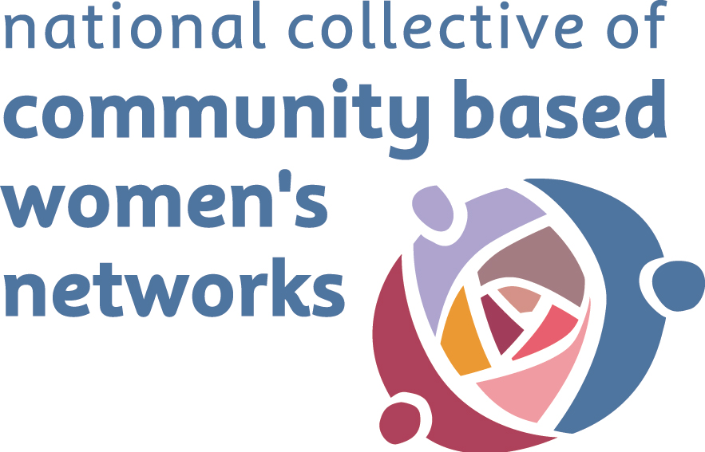
NORTH LEITRIM WOMEN’S CENTRE

SPRING/SUMMER 2018 SCHEDULE OF COURSES AND ACTIVITIES
The North Leitrim Women’s Centre, The Bee Park Centre, Manorhamilton, Co. Leitrim
Tel. No. 071 98 56220 Fax. 071 98 56050 Email: nlwrg@eircom.net
www.northleitrimwomenscentre.ie

COURSE | TIMES & DURATION | VENUE | COST
Breads, Pastries and Deserts - QQI Level 4  Learners will demonstrate basic skills such as; Produce sweet and savoury scones and bread, make a Victorian sponge, prepare a range of deserts, produce shortcrust and puff pastry, make a cake and decorate with almond paste, prepare and present afternoon tea trays to include sandwiches, scones and pastries, demonstrate a basic understanding of food cost and quality control, comply with food safety and hygiene legislation and regulations in personal and work practices. | Saturdays 10am-1pm  Course starts Saturday 7th April  12 weeks | The Food Hub  Drumshambo | Funded by  Mayo, Sligo and Leitrim Education and Training Board  Material cost €5 per session
Certificate in Office Skills - QQI Level 4  Modules will include Communications, General office skills, Business English, Mathematics, Word processing, Customer service, Computer applications, Data entry, Work experience | Induction – Wednesday 2nd May  Course Starts- Wednesday 9th May  10.00am – 4.30pm | North Leitrim Women’s Centre,  Bee Park Centre,  Manorhamilton | Free - Funded by  Mayo, Sligo and Leitrim Education and Training Board
Basket Making Course  with Tom O Brien  Learn the art and skill of basket masking with 4 week course. All materials provided and each participant will make their own unique basket – limited places available | Saturdays- 10.00am – 3.30pm  3 Weeks  24th March, 7th April & 14th April | North Leitrim Women’s Centre,  Bee Park Centre,  Manorhamilton | Funded by the Mayo, Sligo and Leitrim Education and Training Board  Materials Cost - €10
Wood Work Skills - Make your own Window Boxes  With Eddie Gilmartin  Learn the DIY skills to make 2 window boxes to take home with you, incorporating some very useful tips which can be used again and again | Tuesdays 7.00pm – 10.00pm  5 Weeks  Starting Tuesday 20th March | North Leitrim Women’s Centre,  Bee Park Centre,  Manorhamilton | Funded by Mayo, Sligo and Leitrim Education and Training Board  Materials cost €25
‘Make your own Fascinator/Hat’ with Leitrim  with Milliner Cora Byrne  Have you a wedding or an occasion coming up or are you just a bit crafty!! Come join us for an introduction into the world of millinery. All participants will produce their own headpiece Basic sewing is essential you don't have to be great just willing to try! | Dates to be Confirmed | North Leitrim Women’s Centre,  Bee Park Centre,  Manorhamilton | Funded by the Mayo, Sligo and Leitrim Education and Training Board  Materials Cost - €15
Easter Flower Arranging  with Triona Warnock  Make your own Easter flower arrangement to bring home plus some gardening information for spring | Friday 23rd March  10.00am – 1.00pm | North Leitrim Women’s Centre,  Bee Park Centre,  Manorhamilton | Funded by the Mayo, Sligo and Leitrim Education and Training Board  Materials Cost - €10 (includes all  materials, flowers, foliage etc)
Card Making  With Maureen  Participants will learn the skills and techniques to produce their own beautiful and unique cards – all participants will produce a number of cards to take home | Tuesdays 2.30pm – 4.30pm  2 Weeks  20th and 27th March | North Leitrim Women’s Centre,  Bee Park Centre,  Manorhamilton | Funded by the IPB Insurance Community Engagement Fund  Materials Cost - €5 per session
Learn the basics of Homeopathic First Aid  This Homeopathy First Aid Course will provide an insight into the philosophical background as well as the basic methodology of first aid and acute prescribing in homeopathy, so that you can use it in everyday situations at home, and on holiday – for yourself, your family and friends! You will be able to treat many first aid situations from cuts, bruises, burns, childhood fevers, teething troubles, ear infections, coughs, flu, vomiting, diarrhoea, headaches etc. The course is divided into six parts, each of which is divided into sections to help you understand various aspects of homeopathy and its practical everyday usage. No prior knowledge of homeopathy or medicine required.This course provides information that can be used not instead of, but in addition to, standard first aid and accident procedures | Thursday 24th May  6.30pm-9.30pm  6 weeks | North Leitrim Women’s Centre,  Bee Park Centre,  Manorhamilton | Funded by the IPB Insurance Community Engagement Fund  Materials Cost - €60  This covers the cost of a ‘Homeopathic Kit’ which includes 42 remedies for participants to use and keep after the course
Discovering the Rainbow Within  With Marie Evans  Looking at the colours within us and learning ways to activate these colours so that we become the rainbow that we are. The workshops will involve some teaching, movement and meditation. Participants will learn to balance colours in our food and in what we wear to enhance our mood and wellbeing We often spend a lot on the external make over. Why not spend some time on the internal make over? | Friday 16th March 10am – 1.00pm  Friday 11th May 10.00am – 1.00pm | North Leitrim Women’s Centre,  Bee Park Centre,  Manorhamilton | Funded by the IPB Insurance Community Engagement Fund
Crochet Class  With Maria Ferguson  Whether you are a complete beginner or you would like to improve your skills come along and learn the basic stitches and leave with a hat or cowl. Pattern reading made easy | Fridays 10.30am-12.30pm  6 weeks  Starting April 20th | North Leitrim Women’s Centre,  Bee Park Centre,  Manorhamilton | Funded by the IPB Insurance Community Engagement Fund  Materials Cost – €15 Euro
STEPS for Women Programme  The exciting new programme offers a comprehensive range of supports and skills for women wanting to return to work, return to education or simply find a new direction in their lives. The course will look at confidence and self-worth, life balance, health & well-being, equality, personal development and life coaching & planning. It will support women to identify existing skills and qualities and how to build on these as well as offering practical skills in areas of IT, social media, communications, interview and presentation skills. | Tuesdays 10.00am – 1.00pm  20 Weeks  Induction/Information Morning – Tuesday 17th April  Course Starts Tuesday 24th April | North Leitrim Women’s Centre,  Bee Park Centre,  Manorhamilton | Free - Funded by the Programme for Employability, Inclusion & Learning (PEIL) 2014-2020 through the Dept. of Justice & Equality
Women’s Health Morning  A Woman’s health and wellness morning with speakers to discuss nutrition and the menopause plus a holistic approach to the menopause. Following the talk there will be light refreshments served. | Friday 13th April  11.30am | North Leitrim Women’s Centre  Bee Park Centre  Manorhamilton
Discover Roscommon  Day trip to The Arigna Mining experience, King House, Boyle and Lough Key Forest Park. 3 course Lunch provided in Whistler’s Restaurant, Boyle. | Saturday 28th April  Bus leaving Manorhamilton at 10am |  | Cost including bus, admission to attractions and lunch €45

See inside for details of other courses and programmes taking place in The North Leitrim Women’s Centre over Spring/Summer 2018

